Hazardous Area Signaling
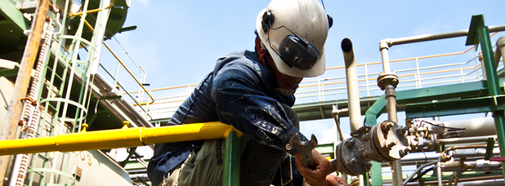
Hazardous areas are defined as areas where concentrations of flammable gases, vapours or dusts may occur, either constantly (Zones 0 and 20), under normal operating conditions (Zones 1 and 21) or unusually (Zones 2 and 22). A whole series of additional conditions relating to the temperature classification and the auto-ignition temperatures of the type of gas or dust to be found ensure that any equipment will not initiate an explosion or fire.
Hazardous areas are to be found in a very wide range of manufacturing industries, far beyond the obvious petrochemical plants. Food, pharmaceutical and cosmetic manufacture all involve processing potentially explosive substances, while the problems of explosions in grain silos and sugar processing plants are very well documented.
There are two ways of ensuring that the alarm sounders or strobes do not initiate an explosion when operated in a hazardous area: explosion proof or intrinsically safedevices.
Simplistically, the input energy entering an intrinsically safe device is constrained so that any arcing or sparking within the unit cannot generate enough heat to start ignition.
The alternative approach, explosion proof, is to house the equipment in an enclosure that is sufficiently robust to prevent any internal explosion from reaching the outside. Clearly, explosion proof devices will, by their very nature, be bulkier, heavier and more robust than intrinsically safe ones, and are therefore more likely to be installed in external applications, particularly as they will be environmentally sealed to IP66 or IP67 in order to achieve the degree of protection required.
For Zones 2 and 22, 'increased safety' devices are required. E2S offers powerful and cost-effective ex sounders and ex beacons for these environments.



